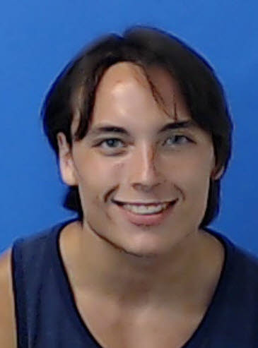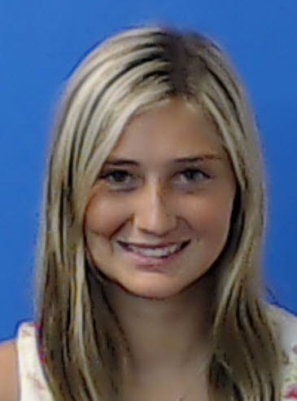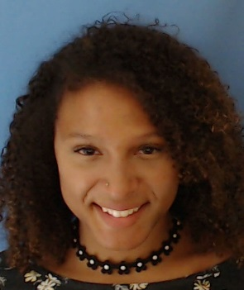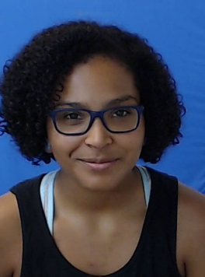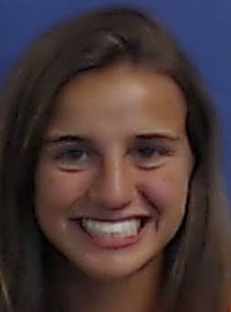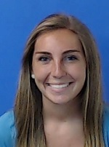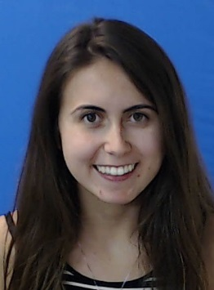

17SU Spain

John Kearney

s1006341

5/20/1996

(201)396-0565

Robin Carlock

s0998398

7/27/1996

(848)207-0684

Hope Avalone

s1042167

11/6/1996

(732)740-3090

Kelly Grant

s0996050

12/2/1996

(908)578-0789

Stephanie Holtje

s0923747

2/5/1996

(917)886-1915

Maritza Darling-Ramos

s1053091

3/4/1997 (773)494-4631

Alivia Carlton

s0993612

8/22/1996

(732)618-6629

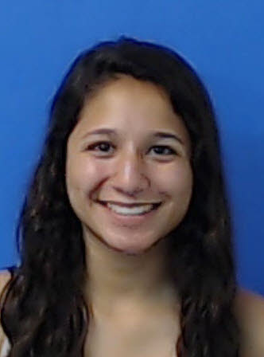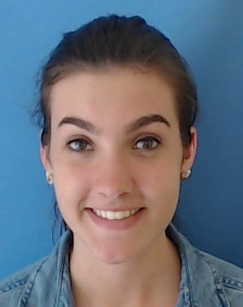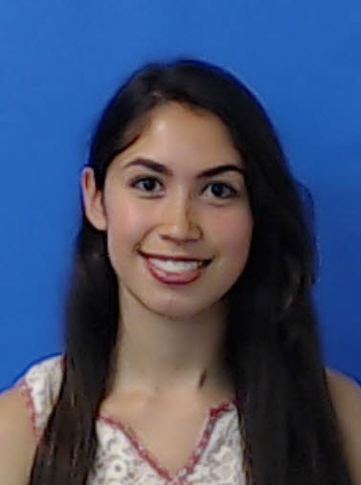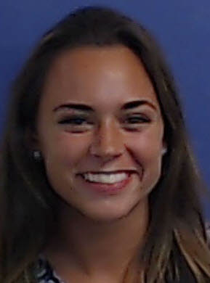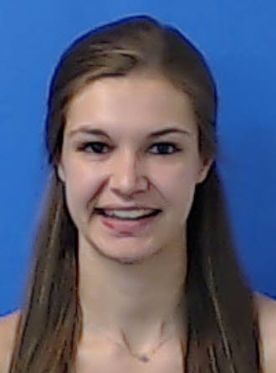

Stephanie Vela

s0971315

8/19/1996

(201)220-1979

Hannah Van Note

s0991952

10/9/1995

(908)489-9769

Isabella Petrocelli

s1000275

8/16/1996

(732)425-8588

Susan Schuld

s0935153

10/27/1995

(732)580-7346

Stephanie Loconsolo

s0988379

12/15/1996

(732)947-6816

John Sabito

s1029046

4/19/1997

(203)727-8340