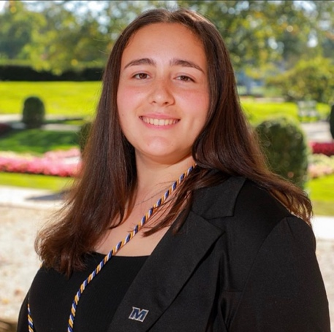
Having Monmouth University as my home for these last four years has been a dream come true. Through all the stress, classes, and COVID, I have still been able to maintain my academic excellence and involvement. Orientation was the start of my full dive into being a member of the Monmouth community the end of my first year. Being on Zoom for orientation, I had to do everything I could to make the student’s first introduction to Monmouth a memorable one. I continued my time with orientation until to becoming an Orientation Team Leader, or OTL, my fourth year. Nothing about my time as an OTL was easy. The work needed to create a cohesive team from a group of nearly strangers was nothing I expected it to be. However, there was nothing that was going to stop me. We had picked a great team of leaders that would make a lasting impression on the incoming students and the team itself was able to come together in support of each other. With changing of administrative positions and even missing pieces, I had to be the glue of the group to get us to our end goal of a successful orientation. No matter how well my partner OTL and I had trained the team there were still bumps in the road that we helped them with. I was excited to gain so much support from the orientation team. Being such a significant example of Monmouth University, representing the pride and passion of the students, was very overwhelming, but the team helped me along to fitting into my role. We are the first people that incoming students see when coming to Monmouth. We share our love for Monmouth and show what being a student is like to get them excited for this next chapter in life. I see an amazing group of new OTLs, returning leaders, and new faces that will continue to make orientation as memorable as it should be and be that example for Monmouth.
From there, I committed to my time to the clubs and organizations that I loved. I took the skills I had learned and put them towards the five executive roles I hold in a variety of clubs and organizations. My two passions have always been my heritage and my career goals. Since there is no Puerto Rican club, I led the Italian club to remain part of this campus for two years first as VP then as President. The Pre-Veterinary club struggled to stay alive, but with new connections and fresh ideas, the club will not be going anywhere any time soon. Being the President of Tri-Beta Biological Honor Society has been such an honor to be an example in the school of science. With being VP of the Senior Class, I have been able to work with amazing people bringing the class together to make such lasting memories. I know that my mark as a leader will make a lasting impression on Monmouth University.

