29th Annual Social Work Day at the United Nations
2012

Partnering with the UN: The Social Work and Social Development Global Agenda – Conference Room 1, North Lawn Building
Thank you to our Supporters
We are grateful to the following Schools, Programs and Organizations for their support of Social Work Day at the United Nations and their support of the Global Social Work Student Conference, which was held on Sunday, March 25, 2012.
Supporters
Adelphi University School of Social Work
Anna Maria College Social Work Program
Boston College Graduate School of Social Work
Brown School of Social Work at Washington University in St. Louis
Bryn Mawr College Graduate School of Social Work and Social Research
Case Western Reserve University-Mandel School of Applied Social Sciences
Columbia University School of Social Work
Fordham University Graduate School of Social Service
Monmouth University School of Social Work
New York University – Silver School of Social Work
Ohio State University-College of Social Work
Rutgers University School of Social Work
Saint Joseph College-Department of Social Work & Latino Community Practice
University of Connecticut School of Social Work
University of Houston-Graduate College of Social Work
University of St. Francis
University of Tennessee-Knoxville
University of Tennessee-Martin
Yeshiva University-Wurzweiler School of Social Work

Collaborating Organizations
Association for Community Organization & Social Administration
Council on Social Work Education
National Association of Social Workers-USA
National Association of Social Workers-Massachusetts Chapter
National Association of Social Workers-New Jersey Chapter

In Support of the Global Social Work Student Conference
Fordham University Graduate School of Social Service
Monmouth University School of Social Work
Rutgers University School of Social Work

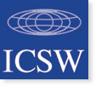
Program

10:00 am Welcome
A Word About our Program – Robin Mama, Co-Chair SW Day, IFSW
Mihi for Helen Clark –Fiona Robertson
Introduction of Helen Clark –Fiona Robertson, IFSW
Presentation of the Global Agenda to UN Dignitaries – Presidents of IASSW, ICSW, IFSW*

10:10 Welcome from the United Nations
Helen Clark, Administrator United Nations Development Program and
Former Prime Minister of New Zealand

10:30 Human Rights and the Global Agenda
Ivan Šimonović , Assistant Secretary-General and High Commissioner for Human Rights, UN-NY

10:50 Missions Respond to the Global Agenda
H. E.Tekeda Alemu - Permanent Mission of Ethiopia to the UN
Chen Yingzhu, Third Secretary of Chinese Mission to the UN

Ministries Respond to the Global Agenda

11:30 The Global Agenda for Social Work
Angelina Yuen, President, International Association of Schools of Social Work*
Christian Rollet, President, International Council on Social Welfare*
Gary Bailey, President , International Federation of Social Workers*

12:10 US Social Work Professions Respond to the Global Agenda
Jeane Anastas – President, National Association of Social Workers
Julia Watkins – Executive Director, Council on Social Work Education

12:40 Q & A – Fill out Evaluations

1:00 Closing Remarks – Janice Wood Wetzel, Co-Chair SW Day, IASSW

Speakers Biographies
( alphabetical order)

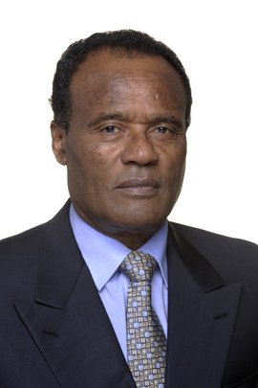
H.E. Tekeda Alemu, Ambassador of Ethiopia to the United Nations Mr. Tekeda was Minister of State in Ethiopia’s Ministry for Foreign Affairs, a post he held since October 2001. For 10 years prior to that, he was Vice-Minister in the Ministry. A career diplomat, he held several posts in the Ministry, including as Head of the African Department (1990–1991) and Acting Head of the Department of International Organizations (1988–1989). Mr. Tekeda headed the Ethiopian delegation at numerous international conferences beginning in 1986.
The new Ambassador penned several publications, including “On the Broader Implications of the Latest Developments in Somalia”, on 8 December 2006, under the aegis of the Japan Institute of International Affairs.
Mr. Tekeda received a doctorate degree in political science from Claremont Graduate School in 1983 and a Master of Arts degree, also in political science, from the University of California at Los Angeles in 1976.
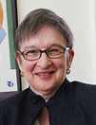
Jeane W. Anastas Professor of Social Work; Director, Strategic Planning and New Initiatives teaches courses in the MSW and PhD programs on social welfare policy, teaching and learning in social work, philosophy of knowledge, and research methods at the Silver School of Social Work, New York University. She is currently serving as the president of the National Association of Social Workers (NASW). She previously served on numerous national committees and boards in social work and social work education, including chairing the ANSWER Coalition working on the Dorothy A. Height/Whitney M. Young Jr. Social Work Reinvestment Act and other legislation to advance social work education and research. In 2007, Dr. Anastas received the Council on Social Work Education's award for the Greatest Recent Contribution to Social Work Education, and in 2011 she received the Distinguished Teaching Medal at New York University. Her book, Teaching in Social Work: Theory and Practice for Educators, was published by Columbia University Press in 2010, and her book on Doctoral Education in Social Work was published by Oxford University Press in January, 2010. .

Gary Bailey, MSW, ACSW is a native of Cleveland, Ohio. He received his BA from the Eliot Pearson School of Child Study at Tufts University in 1977; and his MSW from Boston University School of Social Work in1979. He is currently a Professor of Practice at the Simmons College School of Social Work; he also holds an appointment as a Professor of Practice at the Simmons School of Nursing and Health Sciences. He holds an appointment as an Adjunct Assistant Professor at the Boston University School of Public Health. Professor Bailey was elected in 2010 President of the International Federation of Social Workers. He is the first person of color to hold this post and only the third North American to do so. In 2010 he was appointed to the Council of Social Work Educations (CSWE) Global Commission. He previously had served on the board of the North American and Caribbean Association of Schools of Social Work representing CSWE.
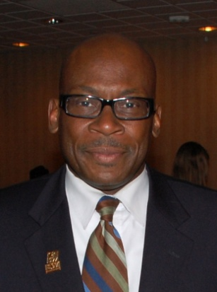
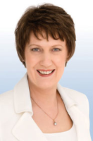
Helen Clark became the Administrator of the United Nations Development Programme in April 2009, and is the first woman to lead the organization. She is also the Chair of the United Nations Development Group, a committee consisting of the heads of all UN funds, programmes and departments working on development issues.
Prior to her appointment with UNDP, Helen Clark served for nine years as Prime Minister of New Zealand, serving three successive terms from 1999 - 2008. Throughout her tenure as Prime Minister, Helen Clark engaged widely in policy development and advocacy across the international, economic, social and cultural spheres. Under her leadership, New Zealand achieved significant economic growth, low levels of unemployment, and high levels of investment in education and health, and in the well-being of families and older citizens. She and her government prioritized reconciliation and the settlement of historical grievances with New Zealand’s indigenous people and the development of an inclusive multicultural and multi-faith society.
Helen Clark advocated strongly for New Zealand’s comprehensive programme on sustainability and for tackling the problems of climate change. Her objectives have been to establish New Zealand as being among the world’s leading nations in dealing with these challenges. Helen Clark was also an active leader of her country’s foreign relations and policies, engaging in a wide range of international issues. As Prime Minister, Helen Clark was a member of the Council of Women World Leaders, an international network of current and former women presidents and prime ministers whose mission is to mobilize the highest-level women leaders globally for collective action on issues of critical importance to women and equitable development.

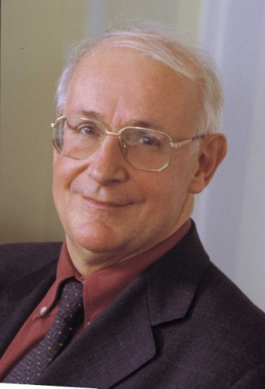
Christian Rollet was elected President of ICSW in 2008 after serving as Treasurer. He is past President of the French Committee of ICSW. Until recently Christian was the General Director of the independent National Social Security Fund for the mines. He graduated from a business school and the National School of Administration. He held different key positions in the French administration for social affairs and in social security institutions. He was President of the Association of School of Public Health in the European region and has extensive experience in international cooperation.

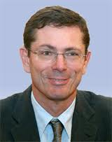
Ivan Šimonovic, Assistant Secretary-General is the High Commissioner for Human Rights, New York office. He is the first person to hold the new post, which was approved by the UN General Assembly in December 2009. Mr. Šimonovic has extensive experience in the fields of international development, human rights, peace building and development of national institutions, which he has addressed at the political and academic levels.

Mr. Šimonovic has been Minister of Justice of the Republic of Croatia since 2008, after previously serving as Assistant Minister and Deputy Minister in the Ministry of Foreign Affairs. He was the Permanent Representative to the United Nations in New York for six years, and served as the Senior Vice-President and President of ECOSOC from 2001 to 2003. Throughout his twenty-year career, he has actively engaged in various human-rights-related activities both as a legal expert as well as a diplomat.

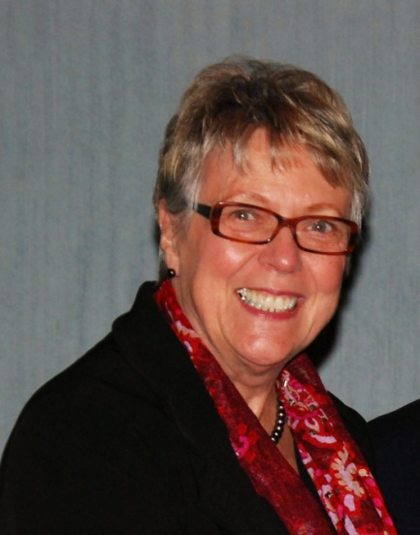
Julia M. Watkins is the executive director of the Council on Social Work Education (CSWE). Previously, she served for 10 years as the President of the American University in Bulgaria. Watkins received an MSW and a PhD in educational psychology from the University of Utah. Before her tenure at the American University in Bulgaria, she was a professor of social work, dean of the college of social and behavioral sciences, and interim vice president for academic affairs at the University of Maine. She has been a fellow of the American Council on Education and is a member of Phi Kappa Phi Honor Society.

Watkins has given numerous presentations and authored many written works, including a book on social policy, as well as research and training grants in the fields of gerontology, social policy, and interdisciplinary training for health care professionals. Her most recent written contributions are in international social work. She has an extensive record of university service and has served on the boards of many nonprofit organizations, both domestically and internationally. Watkins served as president of the Association of American International Colleges and Universities from 1998-2000, and as president of the Alliance of Universities for Democracy (2000-2002). She currently serves as the elected treasurer of the International Association of Schools of Social Work.
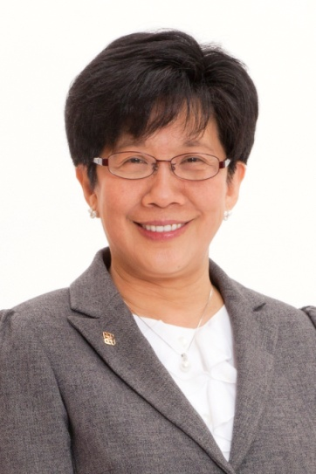

Angelina Yuen - Professor Angelina Yuen is Vice President (Institutional Advancement and Partnership) of The Hong Kong Polytechnic University (PolyU). Professor Yuen completed a bachelor degree in social science, MSW, MEd and Doctor of Philosophy (Social Work and Social Administration).

Professor Yuen was President of the Hong Kong Social Workers Association (2000 – 2004) and has served as a board member of numerous Government commissions, NGOs and charitable foundations; these include the Social Workers Registration Board, Hong Kong Council of Social Service, Hong Kong Press Council, Commission on Strategic Development, Election Committee, Keswick Foundation, Community Investment and Inclusion Fund, and Ping Wo Fund. She was appointed as a Justice of the Peace in 2002 and received the Bronze Bauhinia Star in 2008.

In the international arena, Professor Yuen is a key player in international social development. She was elected President of the International Association of Schools of Social Work in July 2008. She has been involved in various other international organisations including the Asian and Pacific Association for Social Work, International Consortium for Social Development, the China-Europa Forum and World Vision.

Social Work Day Planning Committee
IASSW: Janice Wood Wetzel, Main Representative
Moira Curtain
Rebecca Davis
Lynne Healy
Terry “MC” Hokenstad
Evelina Pangalangan
Rosa Perla Resnick
Nicole Fink, Social Work Intern, University of Connecticut

IFSW: Michael Cronin, Main Representative
Elaine Congress
Robin Mama
Marcia Wallace
Bethany Andrade, Social Work Intern, Monmouth University
Eva Lessinger, Social Work Intern, Fordham University

Links and Materials

The Global Agenda for Social Work and Social Welfare - http://www.ifsw.org/p38002163.html
International Association of Schools of Social Work - http://www.iassw-aiets.org/
International Federation of Social Work - http://www.ifsw.org/home
International Council on Social Welfare - http://www.icsw.org/
2008 Annual Social Work Day at the United Nations: An Anniversary Celebration Featuring Human Rights and Social Work - http://www.cswe.org/File.aspx?id=25145
International Social Work
Cox , D., & Pawar, M. (2006). International social work: Issues, strategies and programs. Thousand Oaks, CA: Sage.
Cronin, M., Mama, R., Mbugua, C., & Mouravieff-Apostol, E. (n.d). Social Work and the United Nations. http://bluehawk.monmouth.edu/swork/UN/rm_cronin_swandun%5B1%5D.pdf
Gray, M. (2005). Dilemmas of international social work: Paradoxical processes in indigenization, universalism and imperialism. International Journal of Social Welfare. 14, 231-8.
Healy, L.M. (2008). Exploring the history of social work as a human rights profession. International Social Work. (51) 6, 735-748.
Healy, L.M. (2008). International social work: Professional action in an interdependent world. 2nd Edition. New York: Oxford University Press.
Healy, L.M, Asamoah, Y., & Hokenstad, M.C. (2003). Models of international collaboration in social work education. Alexandria, VA : Council on Social Work Education.
Healy, L.M, & Link, R. J. (2012). Handbook of International Social Work: Human Rights, Development, and the Global Profession. Oxford University Press.
Hokenstad M.C., & Midgley, J. (2004). Lessons from abroad: Adapting international social welfare innovations. NASW Press.
Hokenstad M.C., & Midgley, J. (1997). Issues in International social work: Global challenges for a new century. Washington, DC: NASW Press.
Hugman, R. (2010). Understanding international social work: A critical analysis. Basingstoke, Hampshire: Palgrave Macmillan.
Ife, J. (2008). Human rights and social work. Revised edition. Cambridge: Cambridge University Press.
International social work Sage Publications. Journal co-sponsored by IASSW, ICSW and IFSW. 6 issues per year.
International Federation of Social Workers. (2005). International policy statement on globalization and the environment. http://www.ifsw.org/p38000222.html
Mapp, S. C. (2008). Human rights and social justice in a global perspective: An introduction to international social work. New York: Oxford University Press.
Mishra, R. (2005). Social rights as human rights: Globalizing social protection. International Social Work, 48(1), 9-20.
Payne, M. and Askeland, G.A. (2008). Globalization and international social work: Postmodern change and challenge. Aldershot, Hampshire: Ashgate.
Ramanathan, C.S. and Link, R.L. (1999). All our futures: Principles & resources for social work practice in a global era. Belmont, CA: Brooks Cole.
Reichert, E. (ed.), (2007). Challenges in human rights: A social work perspective. New York: Columbia University Press.
Seibel, F.W. (2008). Global leaders for social work education: The IASSW presidents 1928-2008. ECSPRESS.
Skegg A.M. (2005). Human rights and social work: a western imposition or empowerment to the people? International Social Work. 48(5), 667-672.
United Nations (1994). Human rights and social work: A Training manual. Geneva: UN Centre for Human Rights with IFSW and IASSW.
Wetzel, J.W. (2007). Human rights & women: A work in progress.” In Reichert, E. (Ed.). Challenges in Human Rights: A Social Work Perspective. NY: Columbia University Press.
Wronka, J. (2008). Human rights and social justice: Social action and service for the helping and health professions. Thousand Oaks, CA: Sage.

