Graduate School Panel

A panel of graduate students sharing THEIR stories
Learn what you can do with YOUR future

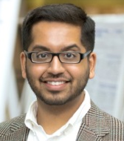
BIOLOGY
Dharm Patel – Ph.D Molecular Biosciences
Rutgers University
MATHEMATICS
Kaitlyn Mascenik – M.S. Statistics
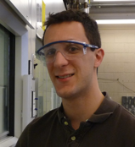
Villanova University
CHEMISTRY
Michael Bessent – Ph.D Chemistry
Rutgers University
ENVIRONMENTAL SCIENCE
Kelly Zimmerman – M.S. Ecology and Evolution
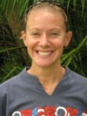
Montclair State University
MARINE SCIENCE
Jeana Drake – Ph.D Oceanography
Rutgers University

November 10, 5-7PM
Wilson Hall room 104

