DEPARTMENT OF HEALTH AND PHYSICAL EDUCATON – ADVISING FORM

1. Bring this completed form to your advising meeting (pages 1, 2, & 3)
2. Bring a copy of your academic audit from WebAdvisor: <https://webadvisor.monmouth.edu/>

|  |  |
| --- | --- |
| **Name: email: Phone:** |  |
| **How many free electives do you have?**  On your academic audit, view “Balance Needed”. Next, add up the credit hours “Not Started” and the remaining credits “Partially Completed”. Subtract this number from “Balance Needed” – the result is the number of credit hours of free electives you have remaining. | Enter # of **free electives remaining** |
| **Have you considered adding a minor?**  <http://www.monmouth.edu/registrar/UG_minors/default.asp> | Yes / No |
| **Have you considered a certificate program?** <http://www.monmouth.edu/registrar/certificates> | Yes / No |
| **Have you considered graduate school?** (Do you know the GPA requirements for the programs you are considering? Did you know master’s degree programs typically range between 30 to 60 credit hours?)  <http://www.monmouth.edu/registrar/GR_curriculum_charts/default.asp> | Yes / No |
| **List the career or careers you are considering:**  [www.monmouth.edu/academics/CSS/undeclared/career.asp#focus](http://www.monmouth.edu/academics/CSS/undeclared/career.asp#focus) | List career(s) |
| **Are you interested in a career in health care?**  Visit: <http://www.monmouth.edu/academics/pre-professional_health> | Yes / No |
| **If you are interested in a career in health care – have you visited the “Preparation” page?**  <http://www.monmouth.edu/academics/pre-professional_health/preparation.asp> | Yes / No |
| **Have you considered (or will you consider) becoming a Certified Health Education Specialist?** <http://www.nchec.org/exam/overview/> | Yes / No |
| **Are there other demands that might influence the number of credit hours you take?** | Yes / No |
| **Have you considered how the number of credit hours you take might impact your GPA?** | Yes / No |
| **Do you plan to take courses during the summer?** | Yes / No |
| **Have you considered studying abroad?** Visit: <http://www.monmouth.edu/study_abroad>  Consider “saving” free electives & courses you want to take abroad. | Yes / No |
| Have you considered a faculty-led trip? <http://www.monmouth.edu/study_abroad/facultyled> | Yes / No |
| **Will you live on-campus? What is your commute time?** | Yes / No |
| **When do you plan to graduate? Circle: May - January - July/Aug** | **Year:** |

To help determine when you will graduate – *complete the table below*. Using your audit, enter the current number of “Balance Needed” credit hours. Next enter the credit hours you expect to complete each semester and subtract that from “Balance Needed”. Eventually, you will arrive at a “Balance Needed” of zero and you will graduate!

**EXAMPLE COMPLETE TABLE BELOW**

|  |  |  |  |
| --- | --- | --- | --- |
| **Semester**  **Example** | **Year** | **Credit Hours you expect to complete** | **“Balance Needed”**  **76** |
| Summer | 2013 | 6 | 70 |
| Fall | 2013 | 16 | 54 |
| Spring | 2013 | 16 | 38 |
| Summer | 2014 | 6 | 32 |
| Fall | 2014 | 16 | 16 |
| Spring | 2015 | 16 | 0 |
| Summer |  |  |  |
| Fall |  |  |  |
| Spring |  |  |  |
| Summer |  |  |  |
| Fall |  |  |  |
| Spring |  |  |  |
| Summer |  |  |  |

|  |  |  |  |
| --- | --- | --- | --- |
| **Semester** | **Year** | **Credit Hours you expect to complete** | **“Balance Needed”** |
| Summer |  |  |  |
| Fall |  |  |  |
| Spring |  |  |  |
| Summer |  |  |  |
| Fall |  |  |  |
| Spring |  |  |  |
| Summer |  |  |  |
| Fall |  |  |  |
| Spring |  |  |  |
| Summer |  |  |  |
| Fall |  |  |  |
| Spring |  |  |  |
| Summer |  |  |  |

**Fall 2013**

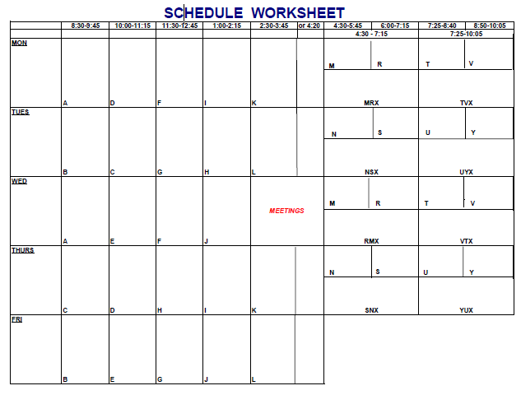

**Spring 2014**



**Summer 2013**

**Summer, fall, & spring schedule**

**Fall 2013**

**Spring 2014**

|  |  |  |
| --- | --- | --- |
| # courses | Course-Section  (i.e. HE160-02) | Credit hours |
| 1 |  |  |
| 2 |  |  |
| 3 |  |  |
| 4 |  |  |
|  | **Total:** |  |

|  |  |  |
| --- | --- | --- |
| # courses | Course-Section  (i.e. HE324-01) | Credit hours |
| 1 |  |  |
| 2 |  |  |
| 3 |  |  |
| 4 |  |  |
| 5 |  |  |
| 6 |  |  |
| 7 |  |  |
|  | **Total:** |  |

|  |  |  |
| --- | --- | --- |
| courses | Course-Section  (i.e. HE440-02) | Credit hours |
| 1 |  |  |
| 2 |  |  |
| 3 |  |  |
| 4 |  |  |
| 5 |  |  |
| 6 |  |  |
| 7 |  |  |
|  | **Total:** |  |