Ultipro Web PUNCH Time Directions
Punching In and Out
- Go to ultipro.monmouth.edu
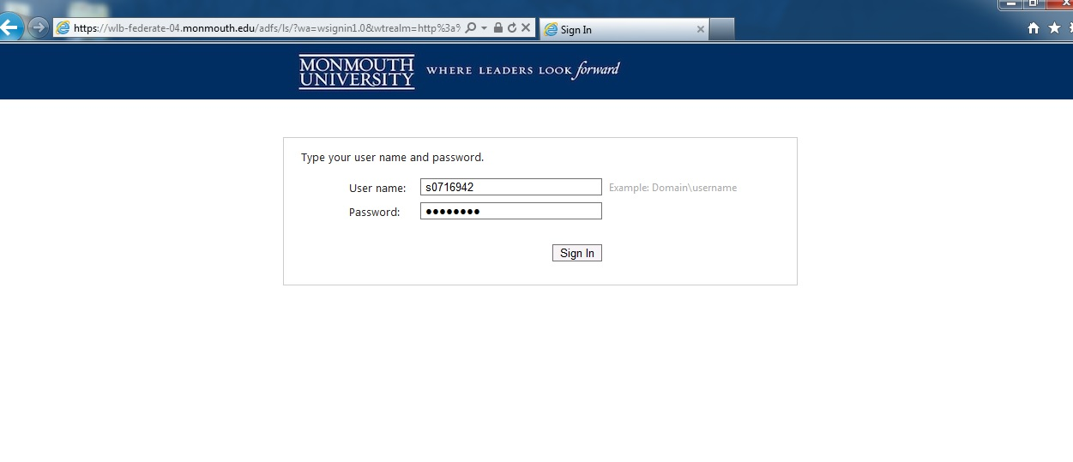
- Sign in using your student id and password

- Hover over the Myself tab and select Time Clock Entry
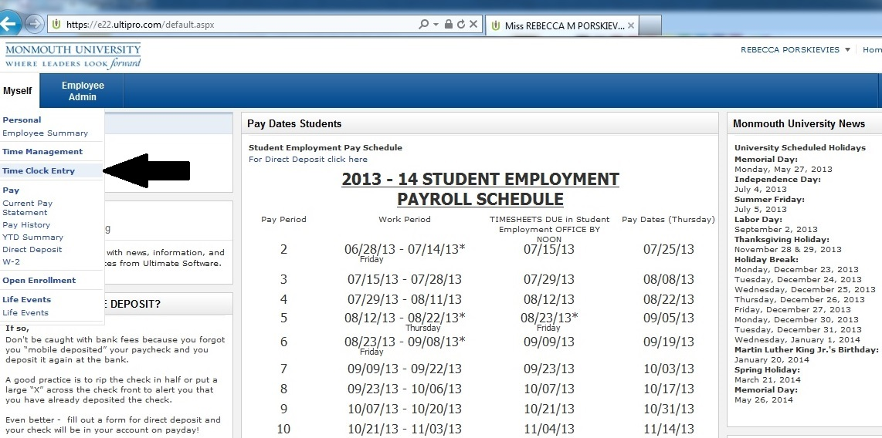

- Select Transfer
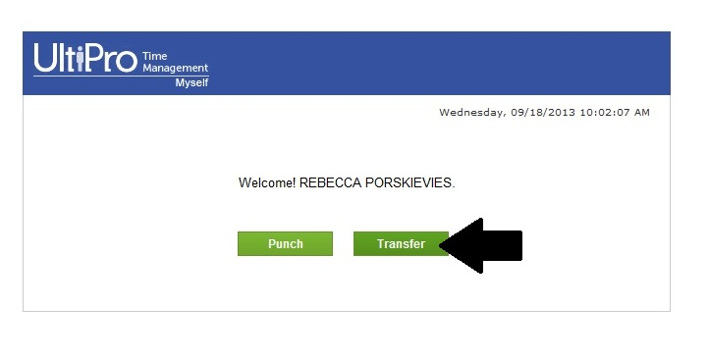
- In the Job drop down select Peer Mentor, in the Department drop down select Honors School, in the Object dropdown select the appropriate option and click Punch.
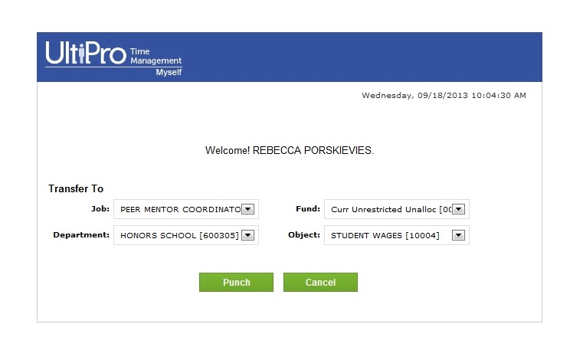

- You should see a screen like the one below. You are now punched in.
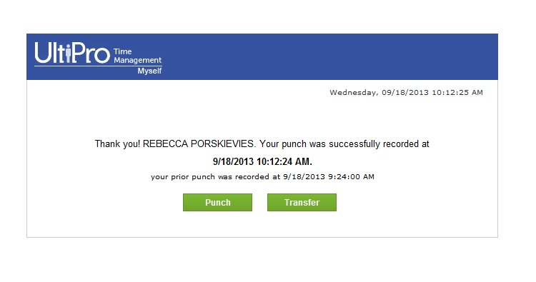
- When you are ready to punch out repeat steps 1-3

- On the Time Clock Entry page click Punch
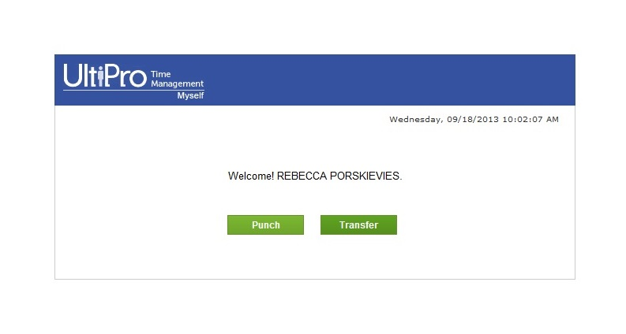

- Again your screen should now look like this. You are now punched out.
- Be sure to logout of Ultipro by pressing Logout on the upper left hand side of the screen
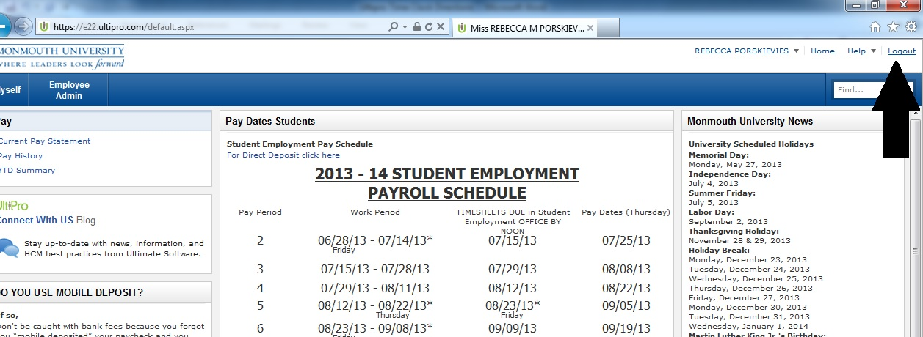

Viewing and Submitting your Timesheet
- Go to ultipro.monmouth.edu
- Sign in using your student id and password

- Hover over the Myself tab and select Time Management (be sure your popup blocker is disabled)
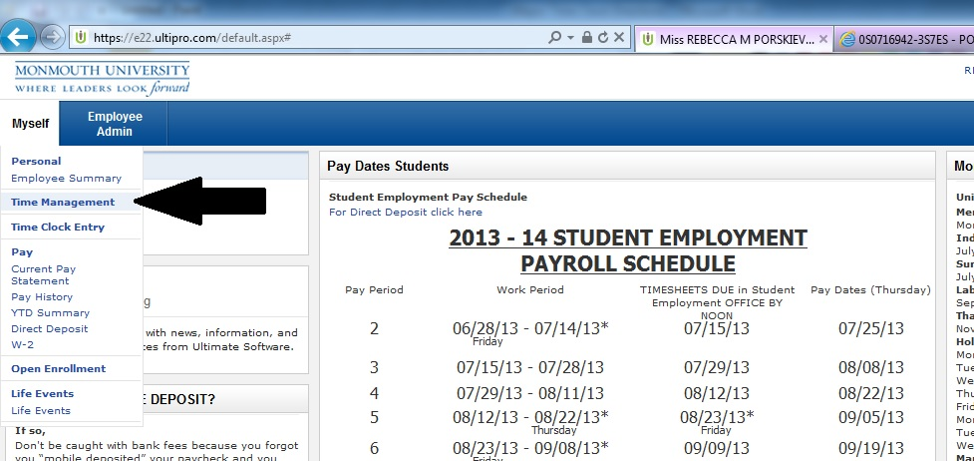

- You will now see a page that looks like the one below.
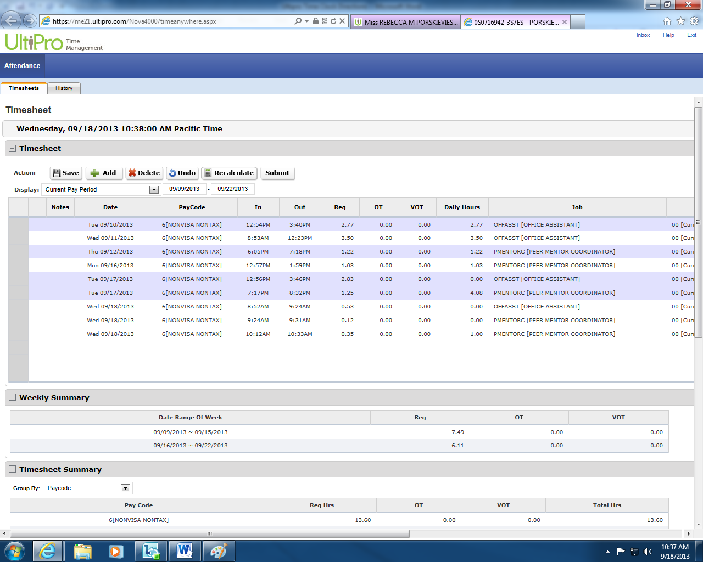
- If you see a red box like the one below, that means you have missed a punch. You need to contact your supervisor to fix this.
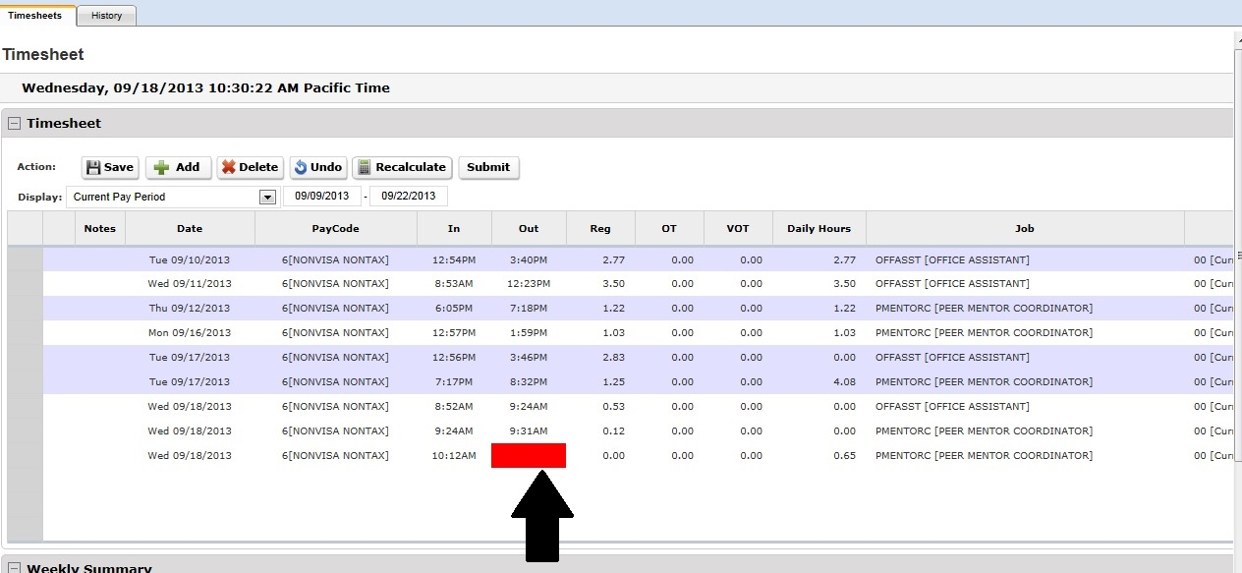
- If you have multiple jobs. Be sure that the Job, Department, and Code are correct for each punch on your timesheet. If you notice one of them is incorrect, click on the Job and a drop down will appear. Select the correct job and click Save.
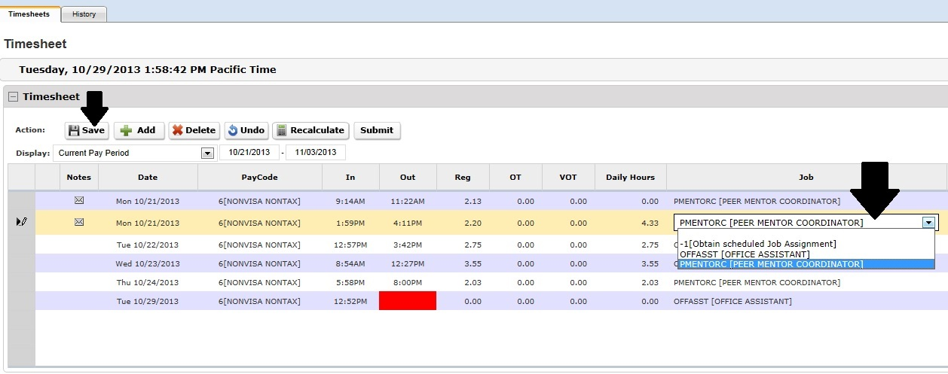
*Note: The same can be done for changing Department or Object.

- If you get out of class early or class is cancelled and you work during the time the class is scheduled, you should utilize the notes section. Highlight the day and click on the pencil.
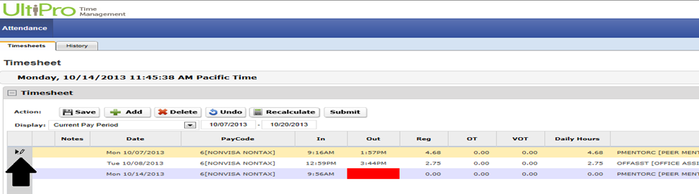

- At this time (see below) the NOTES section will appear. It is imperative that if a class is let out early or cancelled and you are working during class time you indicate such in
The NOTES section below. Then click OK.

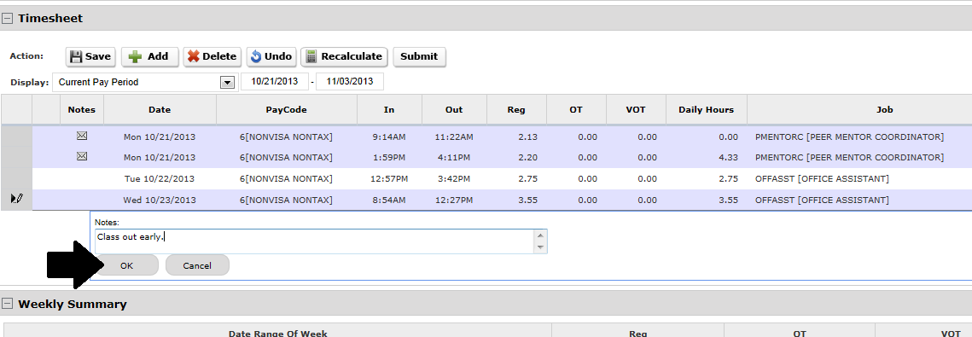

- Lastly, click on the SAVE button to save all entries.
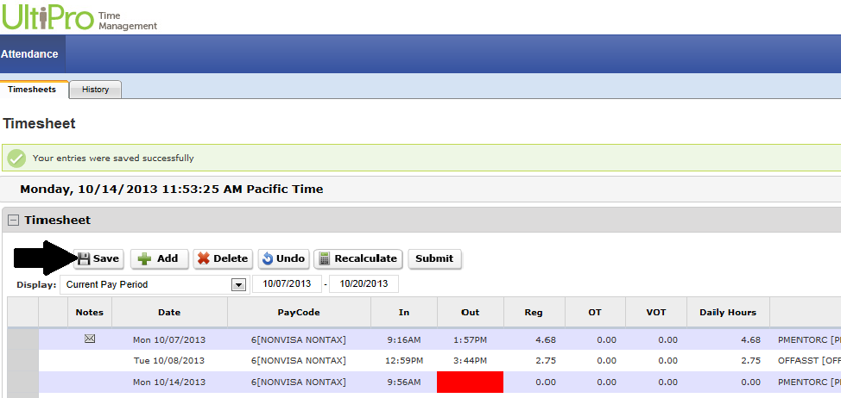

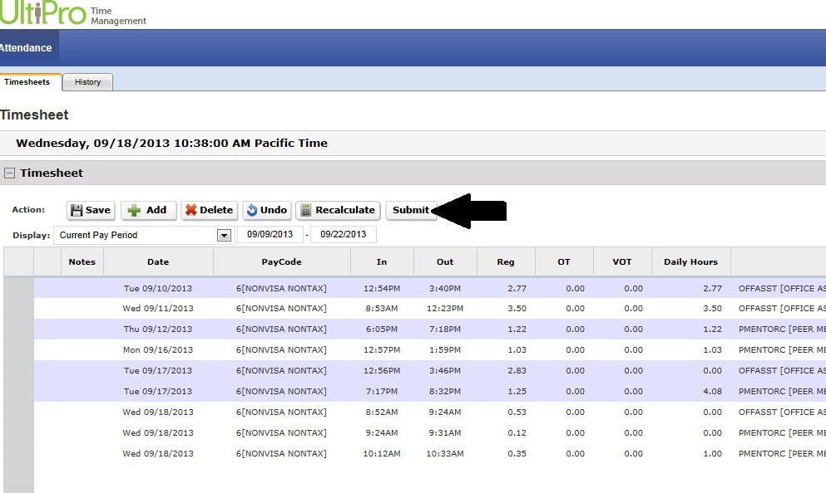
- At the end of the pay period you need to submit your timesheet. On the Time Management screen click Submit.

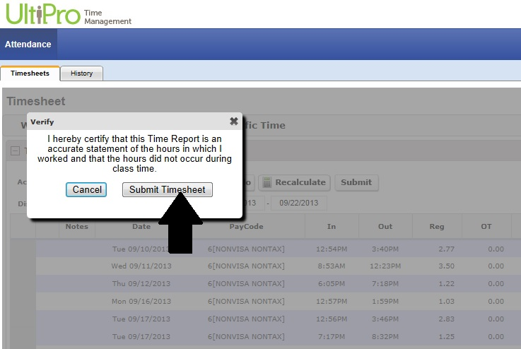
- You will see a box pop up like the one below. Click Submit Timesheet. Your timesheet has now been submitted.

- On the upper left hand side of the Time Management Screen click Exit.
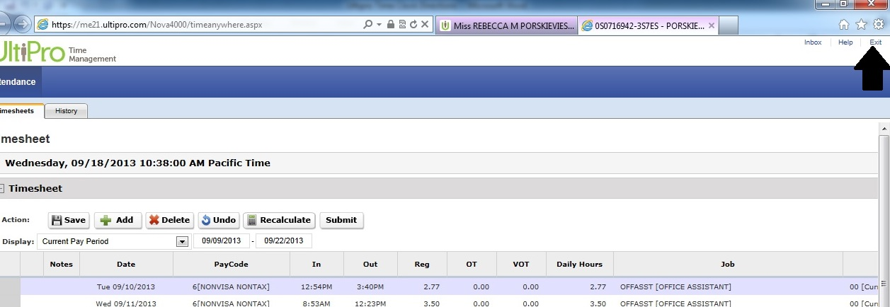

- Be sure to logout of Ultipro by pressing Logout on the upper left hand side of the screen.

