Monmouth University Ultipro Touchbase Clocks
Idle Screen – touch screen to begin

Sign In Screen (with live camera preview)
You must be in view of the camera for the clock to work.
- Enter your Student ID - no leading zero and Hit GO
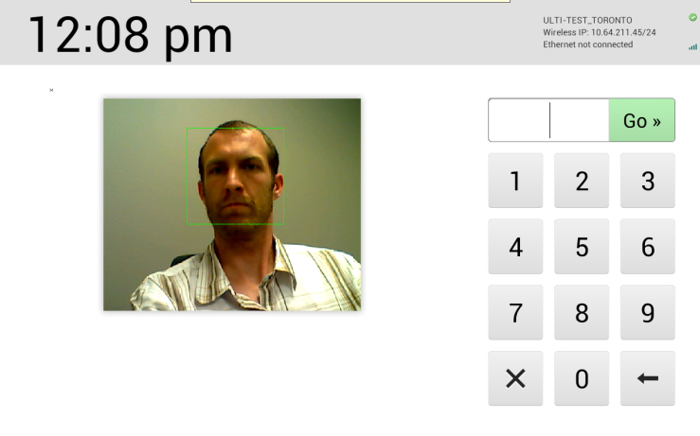

Employee Home Screen (shown after successful Student ID entry)
- Choose your option
- We will choose Clock In
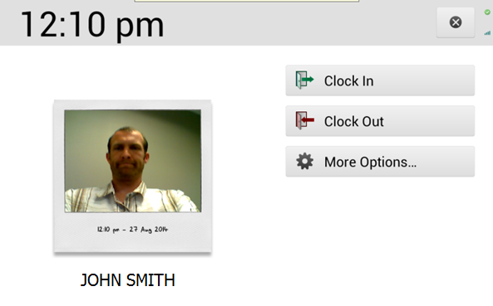
- Input Labor codes (displays for all employees after pressing “Clock In” from Employee Home Screen):
  - Click the word Fund to enter the correct Fund
  - Click word Object to enter the correct Object
  - Click word Department to enter the correct Department
  - Click word Job to enter the correct Job
  - Click Submit once all entries appear
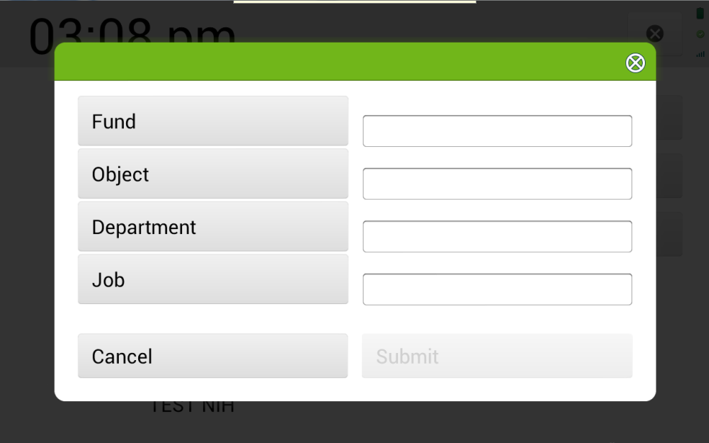
Labor code selection screen (Job selection screen is shown below, this displays after clicking “Job” in screen shot above –others are exact same, just different labor type):
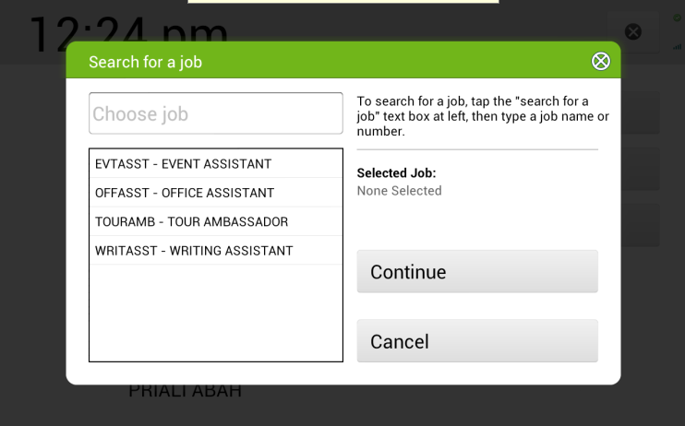
Once you select all the labor codes and click Submit
Clock IN Confirmation screen appears
(See message below)
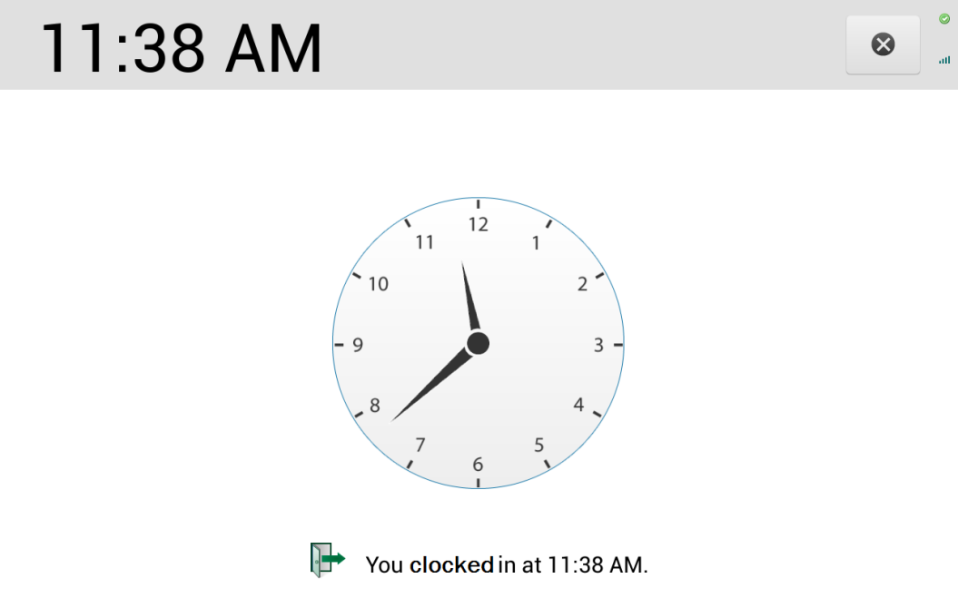

Daily Summary (shown on Clock Out Punch – the timer starts at 15 seconds and counts down to 0 before employee is automatically checked out; they can press “Continue” or “Something is wrong” anytime):
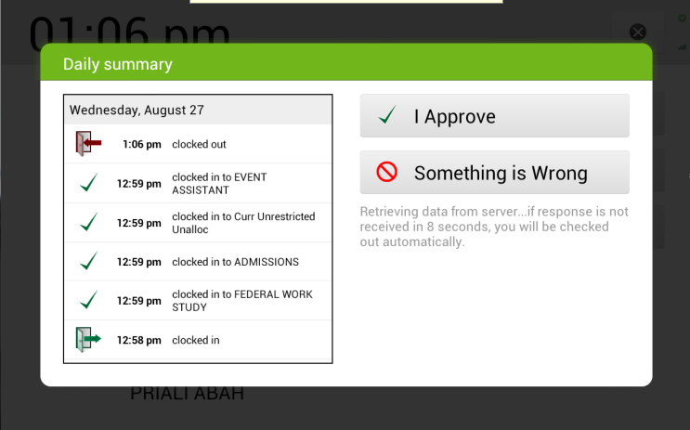
Continue
Pop up message shown if employee selects “Something is wrong”
Choose this option and immediately notify you supervisor of the error so it can be correct.
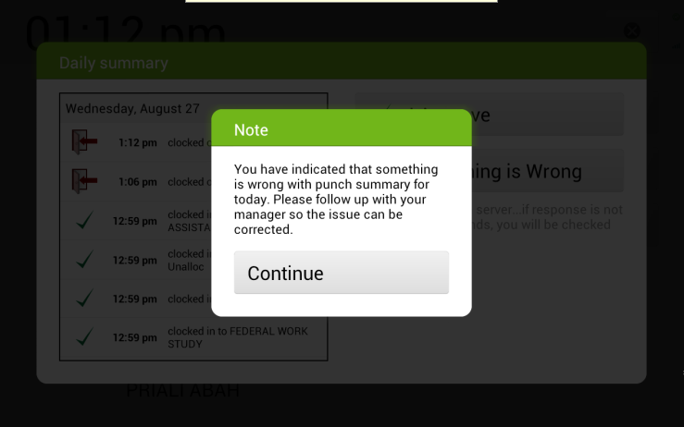

Clock Out Confirmation screen (displayed after Daily Summary; this confirmation screen is displayed if employee selects “Continue” or if the select “Something is Wrong”)
(See message below)

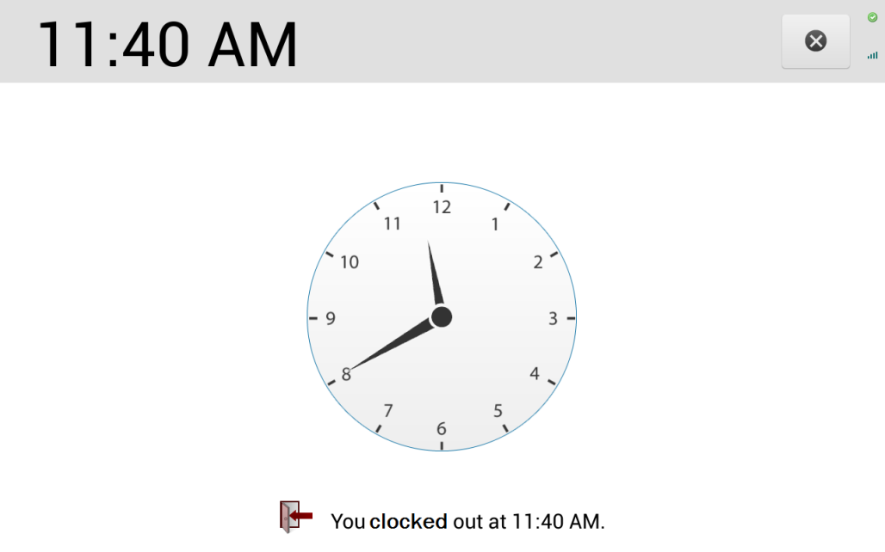

More Options Screen (displayed when “More Options” is selected from Employee Home
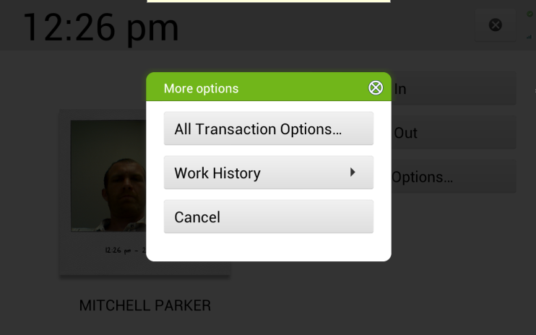

Work History Screen (displayed if “Work History is selected from “More Options” menu)
If there is something wrong you must notify your supervisor immediately to have it corrected.
