UltiPro Time Clock Supervisor Directions
Viewing and Approving Student Timesheets
- Go to ultipro.monmouth.edu
- 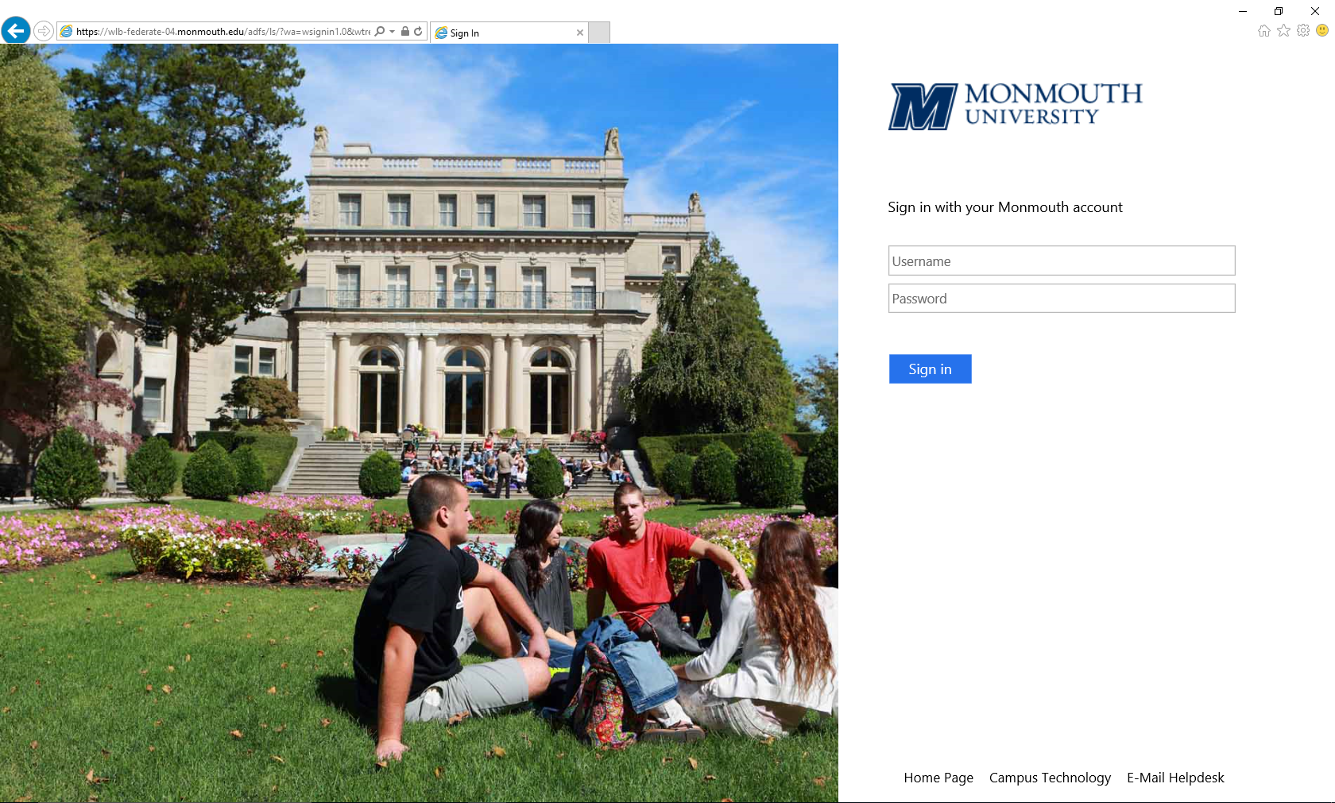Sign in using your regular log in and password

- Click MENU located at the upper left hand side of the screen, hover over the My Team tab and select Time Management (be sure your popup blocker is disabled).
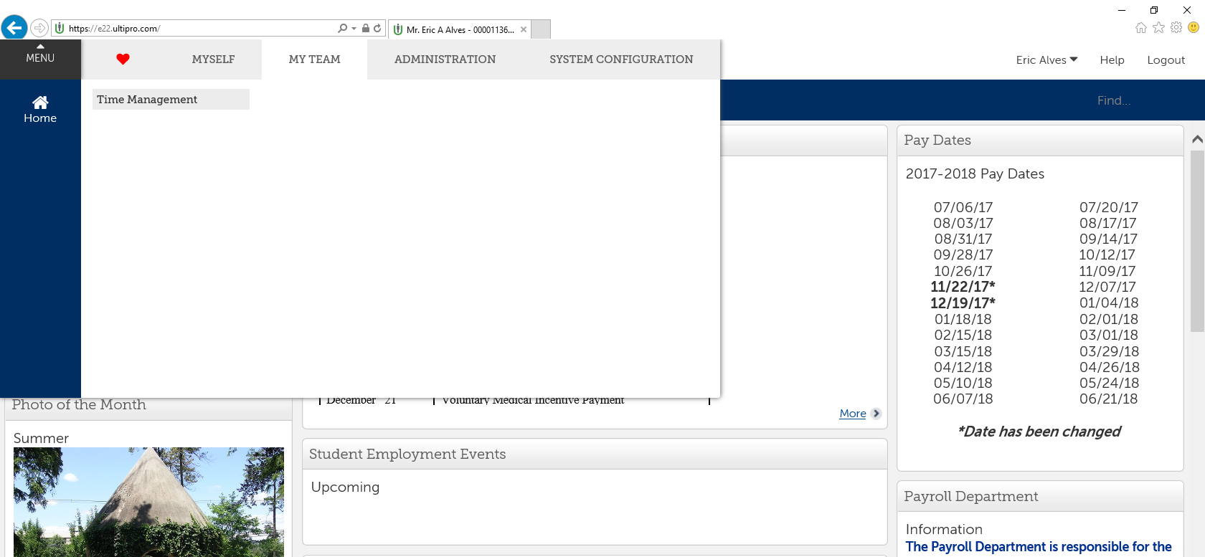

- You will now see a page that looks like the one below.
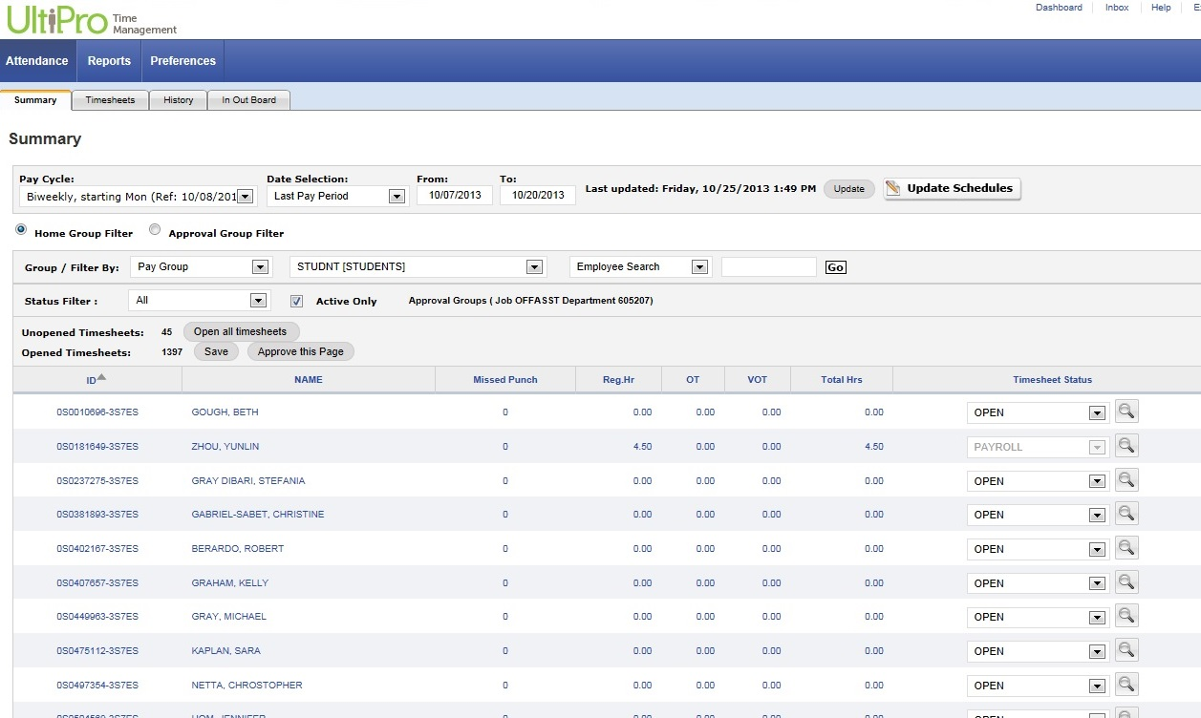

- To view a student’s timesheet, click on the Name of the student you wish to view. You can search for a student using the Search bar.
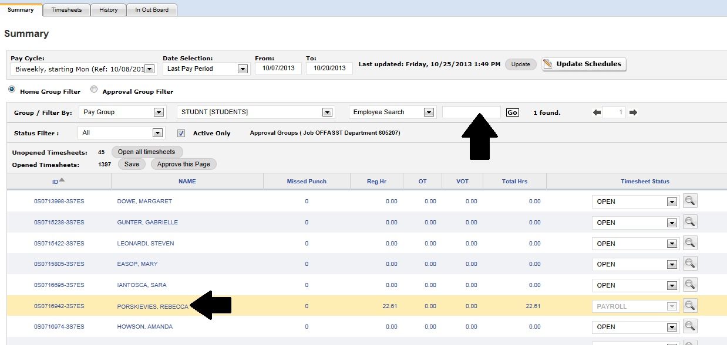

- Check the punches on the student’s timesheet are accurate.

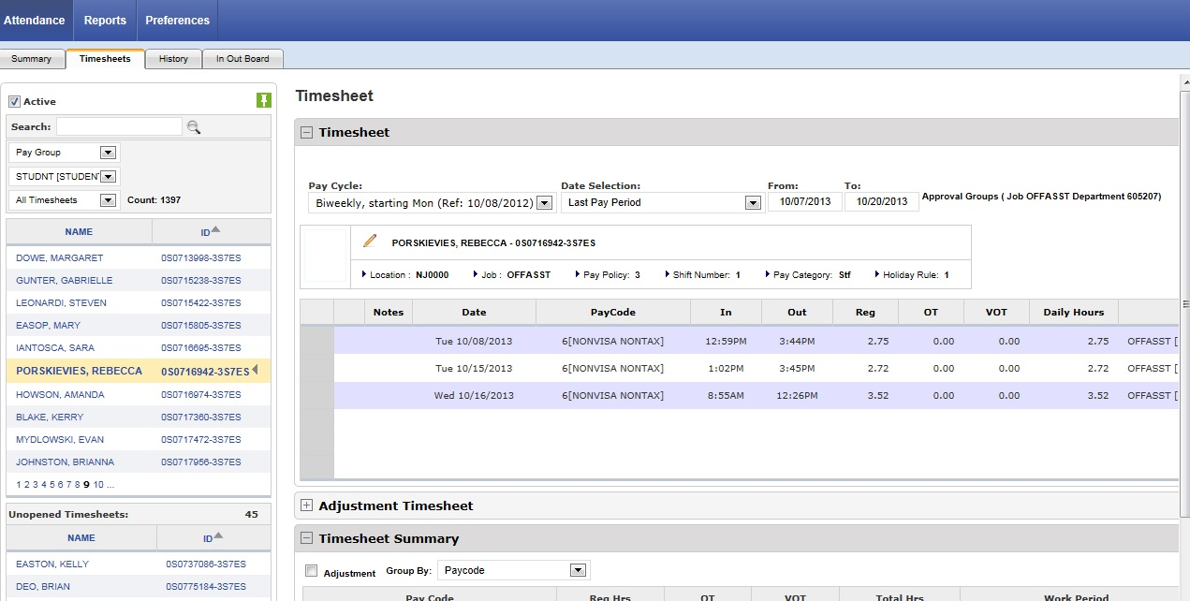

- If you see a red box like the one below, this means that the student has missed a punch. To correct this click on the red box and enter the time the student should have punched out. Be sure to enter AM or PM for the time. Click Save.

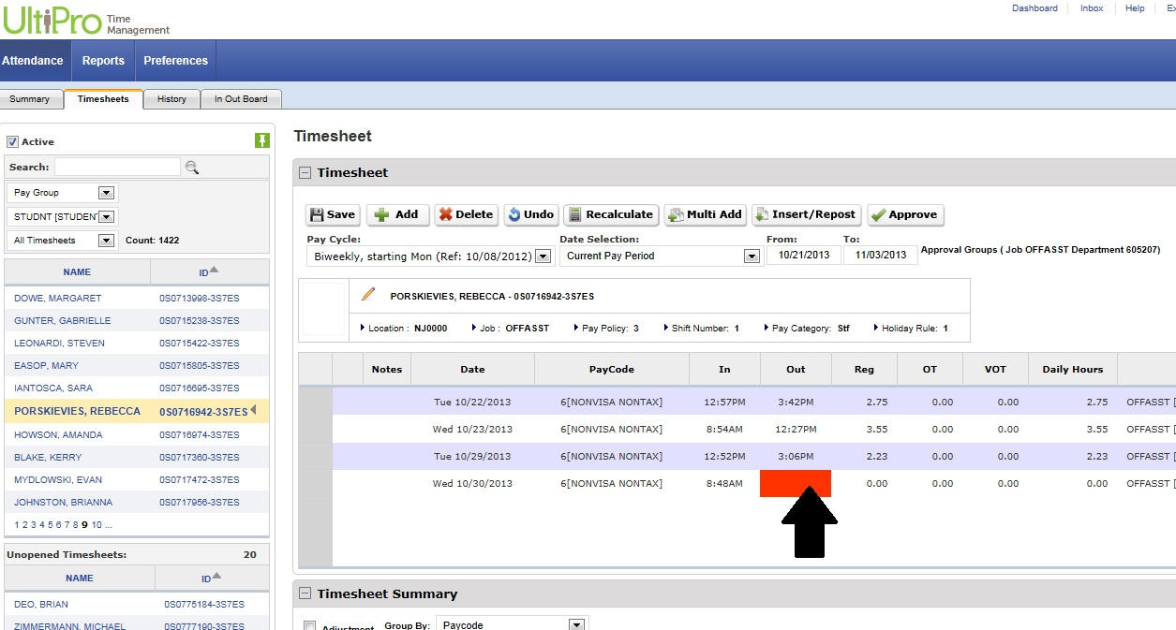
- If you need to add a complete punch to a student’s timesheet, click a blank area in the Date column. Choose the date you are adding a punch for. Enter the In and Out times, select the appropriate Job and Department and click Save.

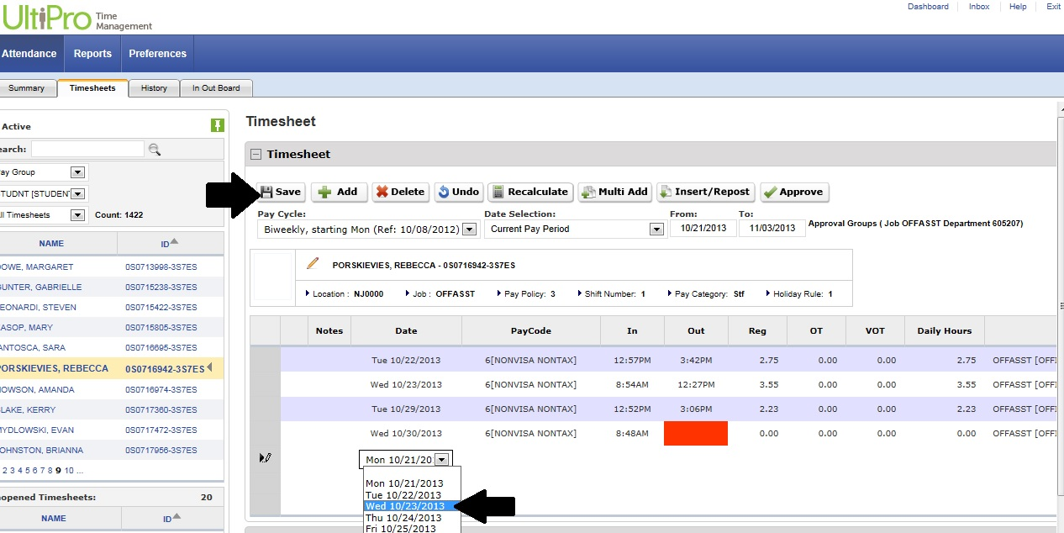

- At the end of the pay period you need to approve all student timesheets. Once the student has submitted it, open the student’s timesheet that you wish to approve. After reviewing the timesheet, click Approve.

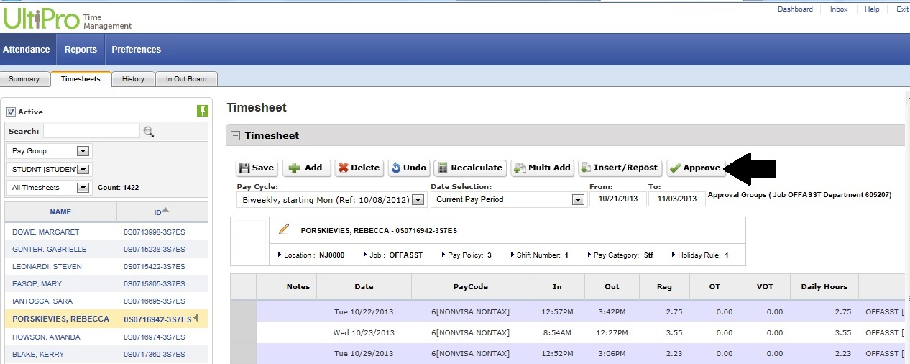

- You have now approved the timesheet. Be sure to do this for each student.

- On the upper left hand side of the Time Management Screen click Exit.

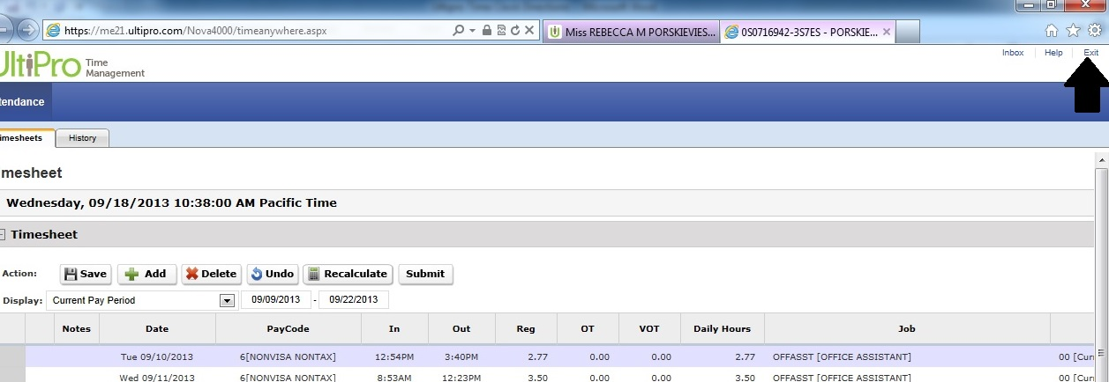

- Be sure to logout of UltiPro by pressing Logout on the upper left hand side of the screen.
