Ultipro Login Instructions

Go to: http://ultipro.monmouth.edu

You will be prompted to enter your Monmouth user name and password.
(The same credentials used to access computers on campus).

If this is your first time logging into Ultipro (MU HR/Payroll System) you need to verify your credentials to gain access. This is to ensure that the person requesting the access is the person of record.

You will be prompted to answer security questions which will be verified against your HR record.

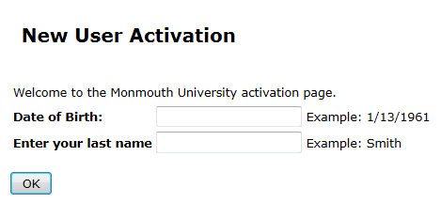

Please note:
- Year of Birth include the four digit year

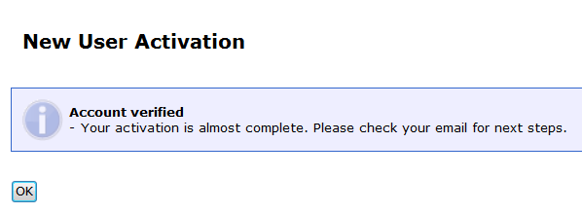

You will get a confirmation email to your MU account; you MUST click to complete your activation.
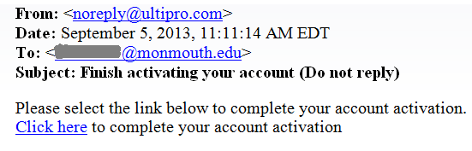

You have been verified and activated – please proceed to login.
