The ABC’s and 123’s of UltiPro

Have you had a hard time remembering everything from UltiPro training?! Attend another one! We also offer “meet & greet” informal meetings to go over issues, concerns, and show new things of the system!
· Students must submit their timecard in order for the supervisor to have the approval option
· Anyone who works 8 or more hours needs to take a half hour unpaid break!
Punch in at the start of the shift, punch out for the break, punch back in after the break, and punch out at the end of the shift.
· Timecards should only be submitted/approved if they are correct!
· Make sure you write & save/read notes on every timecard!
· Deadlines– if a student misses a pay period deadline, they have until the next pay period deadline to submit/approve the timecard. If they miss the second deadline– any Federal Work Study hours becomes Student Help AND the student is not allowed to work on campus until they are in compliance with Student Employment.
· When a student misses a punch, they are emailed the next morning from the system to remind them to leave a note and to notify supervisors. Supervisors then can go in and fix the missed punch!
· Students should submit after they are done working for the pay period. If they submit early or by accident they can “undo submission” before their supervisor approves. Once their supervisor approves the timecard, the only way to submit hours is to have Student Employment re-open the timecard.
· Supervisors only see students on their summary page if that supervisor is their primary job OR once the student punches in for that job.

Clocking In/Out Using the TouchBase Clocks!

We have FIFTEEN TouchBase clocks installed! It is the fastest way to punch in/out of work.

At the beginning of a shift:
· Enter your student ID number
· Press “Go”
· Press “Clock In”
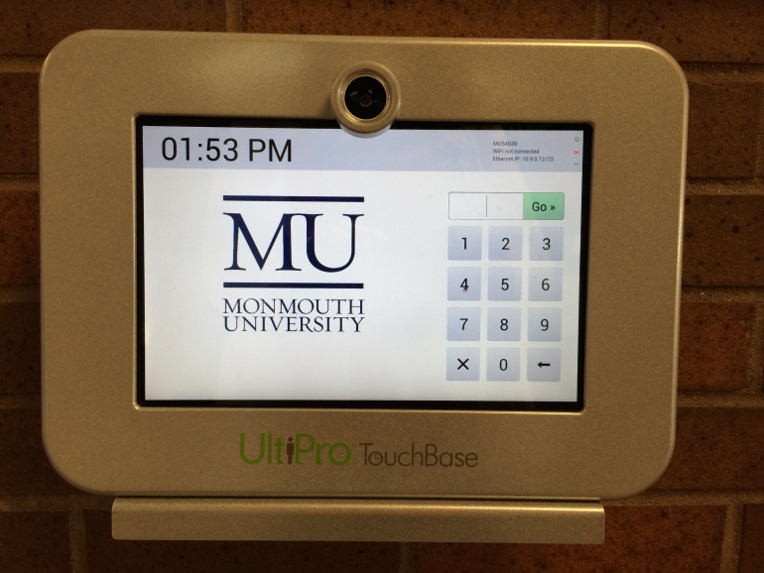
· There are 4 questions- “Fund,” “Object,” “Department,” and “Job”- press each word and select the correct option (most only have 1 option)
· Press “Submit”
· You will see a clock that says “You clocked in at ____”
· Go work!

At the end of your shift:
· Enter your student ID number
· Press “Go”
· Press “Clock Out”
· You will see a summary of the day– press “Continue”
· You will see a clock that says “You clocked out at ____”

