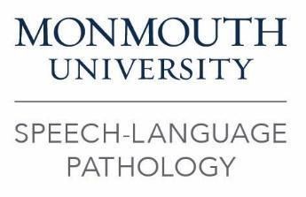

Speech-Language Pathology Program Manual Acknowledgement

I, [TYPE NAME], have received the link to the Monmouth University’s Speech-Language Pathology Program Manuals. This includes the Graduate Handbook, The Policies and Procedures for the Center for Speech and Language Disorders, and the Clinical Externship Handbook. I understand that it is my responsibility to abide by the rules and regulations set forth within this document. I am aware that failure to comply with information set forth in these manuals/handbooks may result in my inability to treat clients in Monmouth University’s Center for Speech and Language Disorders or at my externship site, and/or may warrant discharge from the program. I further understand that I am responsible to adhere to any changes or updates which are made to the manuals/handbooks. I understand the manuals/handbooks are subject to change at any time.

_________________________________ __________________
Student Signature Date

____________________________________ __________________
Director, Center for Speech and Language Disorders Date

